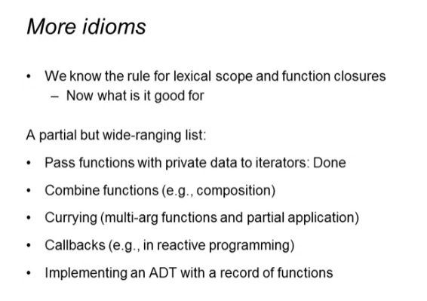

Example of function composition



Syntax:

* <function1> o <function2>

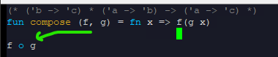

More examples

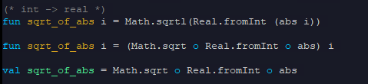

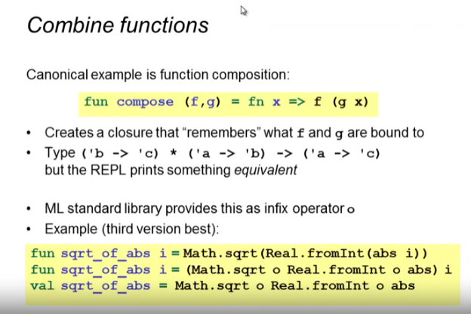

* 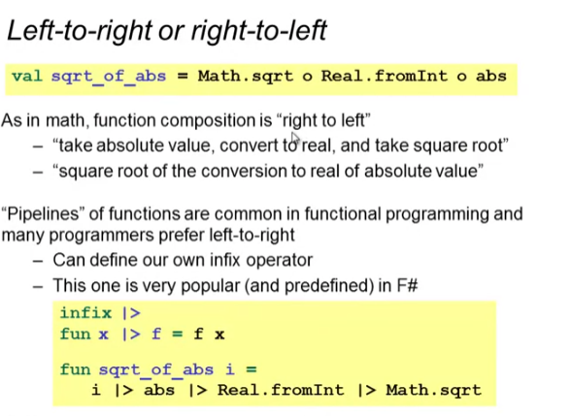we can make our own infix operator if we want to read it from left to right
  + infix <operator>

Examples of pipeline so we can read from left to right

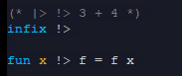

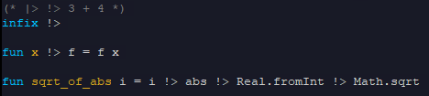

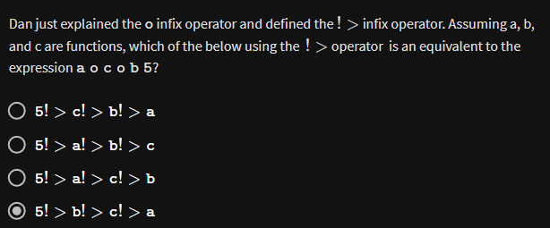

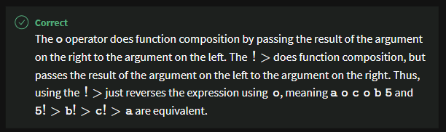

More examples of pipelines







